Name of School
Agenda/Minutes
date

Team Members/Roles Present:

Next Meeting Date:

PAST ITEMS: (5 MINUTES)

ITEM | Person(s) Responsible | STATUS  Done/In-progress | NEXT STEPS/CONCERNS/ COMMENTS

SCHOOL-WIDE DATA: (25 MINUTES)

FOCUSED DATA DIG: (Look at last year’s number of ODR’s, ISS days and OSS days for the meeting month. Then compare to where you are this year. For example, compare ODR’s, ISS and OSS Days given in the month of August 2017 to ODR’s, ISS and OSS Days given in the month of August 2018.)
Last Year’s ODR’s, ISS days & OSS Days This Years ODR’s, ISS & OSS Days
(Month of) _____________: (Month of) _______________:
# of ODR’s ______ # of ODR’s _______
# of 17-18 ISS days______ # of 18-19 ISS Days_______
# of 17-18 OSS days_____ # of 18-19 OSS Days______

WHAT DOES THE DATA TELL US? Let’s Drill Down.
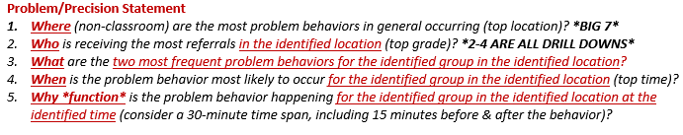

Precision Statement Development:
In general, most ORD’s are occurring in (location) with the (grade level). The most frequent problem behavior for this grade level in this location is
(problem behavior). This problem behavior is most likely to occur at (time) and is likely related to . (perceived motivation)

WHAT IS THE SMALLEST CHANGE WE CAN MAKE TO PRODUCE THE LARGEST IMPACT?
(New teaching of behavior focused lesson plans or re-teaching, pre-correction, increase supervision, increase acknowledgements, increase consistency)

WHAT DATA/INFORMATION DO WE NEED TO GIVE TO THE GRADE LEVELS, DEPARTMENTS, or OTHERS?

MONTHLY TARGETED FOCUS AREA: (10 MINUTES)

CELEBRATIONS: (10 MINUTES)

NEW ACTIONS: (10 MINUTES)

DATA DRIVEN ITEMS  What needs to get done? | What Strategy? | By Whom?  By When?
CALENDAR ITEMS  What needs to get done? | What Strategy? | By Whom?  By When?

COMMUNICATION WITH STAFF: (10 MINUTES)

School-wide data successes to be shared?  (Reduction of a target behavior, % in attendance, % referral free, % going to Celebrations, etc.) | How to share it? With whom?  (brief memo/flyer, email, next faculty meeting, with staff, with parents, with district administration)

